**Flagging + Routing Payment & Non-Standard Billing Terms to Deal Desk**

Both the Agreement Payment Term and Non-Standard Billing term fields are located on the Quote, in the Quote Header Details section in middle of page:

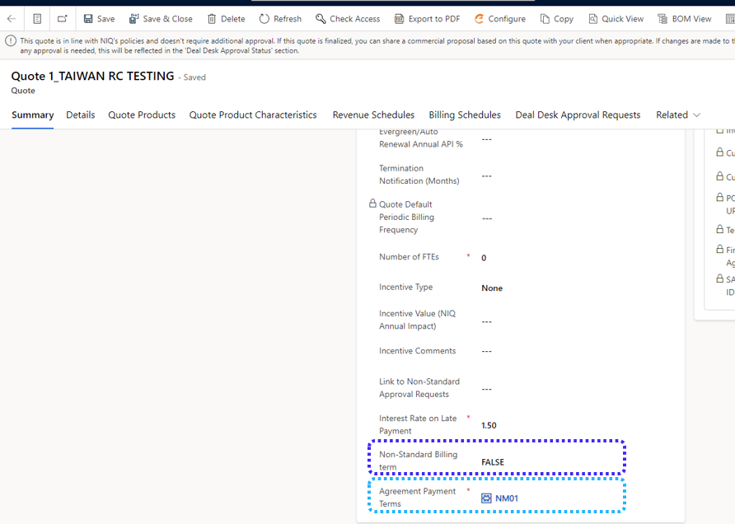

**next page**

1. **Change the field values for either Non-Standard Billing term and / or Payment Terms.**

For non-standard billing terms, change the ‘FALSE’ to ‘TRUE’. If needing to change payment terms, remove NM01 from the field value, and replace with the appropriate code from the picklist available.

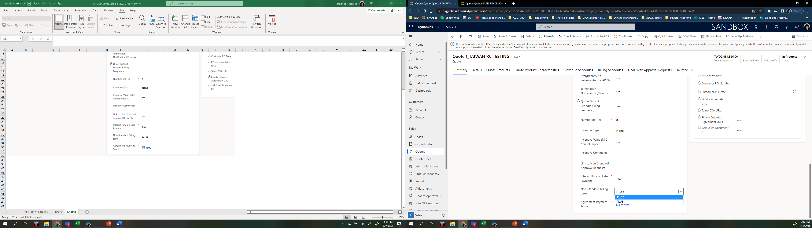

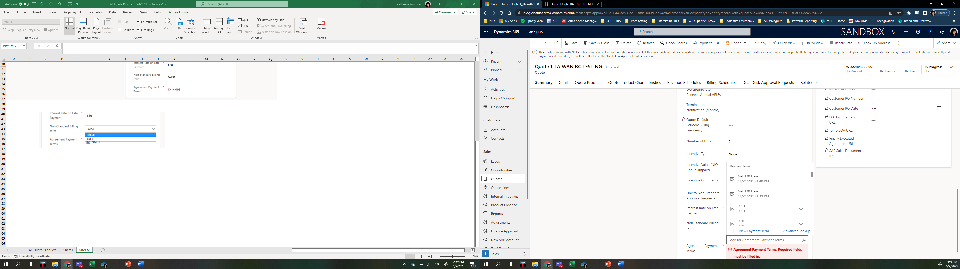

1. **Click ‘Save’ in the Demand Ribbon**

Saving the changes (1) will trigger the check against the Approval fields on the Quote, which should then reflect ‘Approval Required’ for Overall Deal Desk and Quote Header Details (2). A new option in the Demand Ribbon will appear to ‘Initiate Deal Desk Approval’ (3).

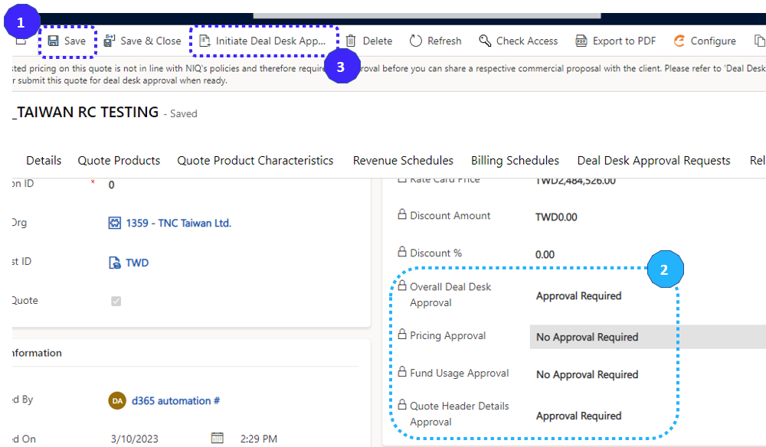

1. **Click ‘Initiate Deal Desk Approval’ and enter in rationale for your Deal Desk Request in Sales comments field**

Upon clicking ‘Initial Deal Desk Approval’ a side window will appear that will include a field for Sales comments where rationale (the “WHAT” and “WHY”) should be entered for Deal Desk review. Once entered, click ‘Save and Close’ at bottom of window, which will submit your request.

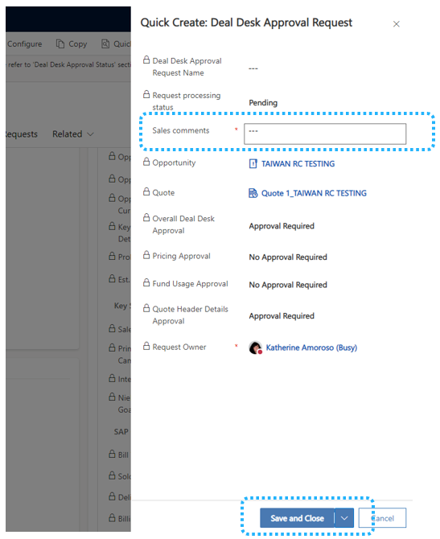

1. **Deal Desk Review**

Deal Desk team will review your request, reach out if clarification is needed, and ultimately make decision as to whether to approve the request. Currently, this process is less than 24 hours. Upon approval or rejection, an email will be sent to the Sales user as notification (example figure 1 below).

The Deal Desk status can always be reviewed within the Quote by clicking on the ‘Deal Desk Approval Requests’ tab (figure 2).

Figure 1:

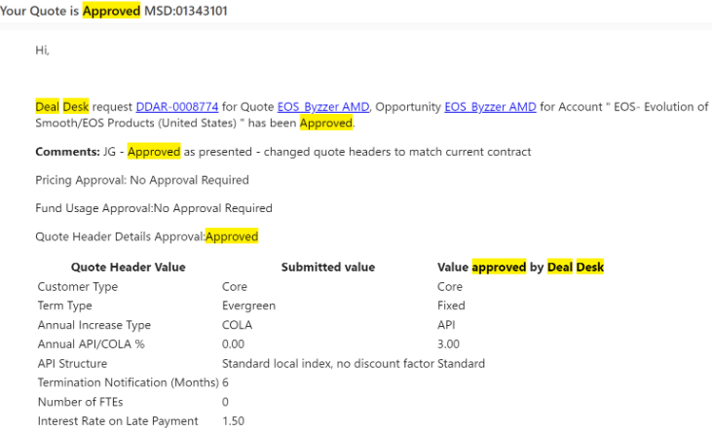

Figure 2: